**//Write a Program to Create database and display table in datagrid control by using database connectivity.**

using System;

using System.Collections.Generic;

using System.ComponentModel;

using System.Data;

using System.Drawing;

using System.Text;

using System.Windows.Forms;

namespace DeviceApplicationnewdb

{

public partial class Form1 : Form

{

public Form1()

{

InitializeComponent();

}

private void Form1_Load(object sender, EventArgs e)

{

// TODO: This line of code loads data into the 'studentDataSet.stud' table. You can move, or remove it, as needed.

this.studTableAdapter.Fill(this.studentDataSet.stud);

}

private void dataGrid1_CurrentCellChanged(object sender, EventArgs e)

{

}

}

}

**OUTPUT:**

**Database:**

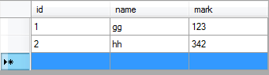

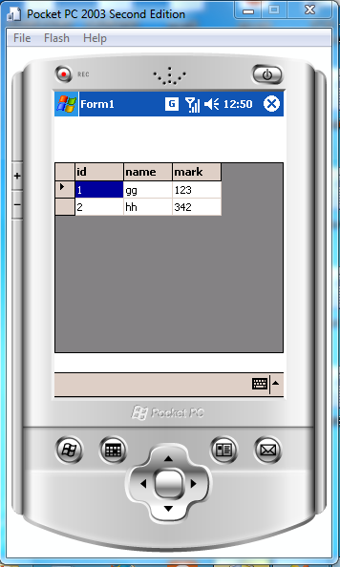

**//Write a Program in a smart device application in C# to demonstrate the difference between prefix and Postfix form of ++.**

using System;

using System.Collections.Generic;

using System.ComponentModel;

using System.Data;

using System.Drawing;

using System.Text;

using System.Windows.Forms;

namespace diksha

{

public partial class Form1 : Form

{

int x;

int[] y = new int[10];

int i;

public Form1()

{

InitializeComponent();

}

private void btnpefix_Click(object sender, EventArgs e)

{

x = 1;

for (i = 0; i < 10; i++)

{

y[i] = x + ++x;

}

txtprefix.Text = y[0] + " " + y[1] + " " + y[2] + " " + y[3] + " " + y[4] + " " + y[5] + " " + y[6] + " " + y[7] + " " + y[8] + " " + y[9] + " ";

}

private void btnpostfix_Click(object sender, EventArgs e)

{

x = 1;

for (i = 0; i < 10; i++)

{

y[i] = x + (x++);

}

txtpostfix.Text=y[0] + " " + y[1] + " " + y[2] + " " + y[3] + " " + y[4] + " " + y[5] + " " + y[6] + " " + y[7] + " " + y[8] + " " + y[9] + " ";

}

}

}

**Output:**

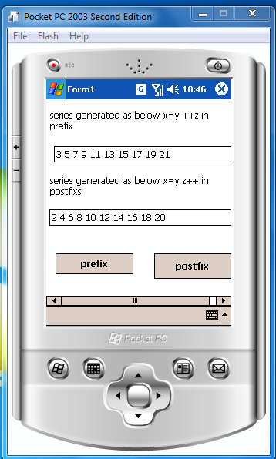

**//Write a program to implement multithreading.**

using System;

using System.Collections.Generic;

using System.Text;

using System.Threading;

namespace ConsoleAppMultithreading

{

class Program

{

static void Main(string[] args)

{

Console.WriteLine("MultiThreading");

Thread tid1 = new Thread(new ThreadStart(MyThread.Thread1));

Thread tid2 = new Thread(new ThreadStart(MyThread.Thread2));

tid1.Start();

tid2.Start();

}

}

public class MyThread

{

public static void Thread1()

{

for (int i = 0; i < 10; i++)

{

Console.WriteLine("Thread1{0}", i);

}

}

public static void Thread2()

{

for (int i = 0; i < 10; i++)

{

Console.WriteLine("Thread2 {0}", i);

}

}

}

}

**Output:**

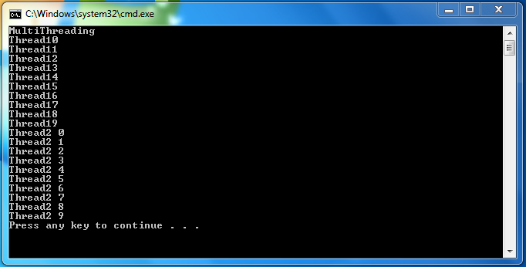

**//Write a program to check whether the number is palindrome number or not.**

using System;

using System.Collections.Generic;

using System.ComponentModel;

using System.Data;

using System.Drawing;

using System.Text;

using System.Windows.Forms;

namespace DeviceApplicationPalindrome

{

public partial class Form1 : Form

{

int num, rem, sum = 0, temp;

public Form1()

{

InitializeComponent();

}

private void button1_Click(object sender, EventArgs e)

{

num = Convert.ToInt32(txtnum.Text);

temp = num;

while (num > 0)

{

rem = num % 10;

num = num / 10;

sum = sum * 10 + rem;

}

label2.Text = "Ehe Reversed Number is :" + sum;

if (temp == sum)

{

label3.Text = "The Number is Palindrome";

}

else

{

label3.Text = "The number is Not Palindrome";

}

}

}

}

**Output:**

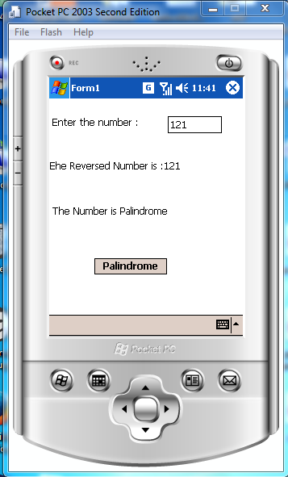

**//Write a program to generate Marksheet of the student.**

using System;

using System.Collections.Generic;

using System.ComponentModel;

using System.Data;

using System.Drawing;

using System.Text;

using System.Windows.Forms;

namespace DeviceApplicationMarklist

{

public partial class Form1 : Form

{

int r, m1, m2, m3, t;

float p;

string n;

public Form1()

{

InitializeComponent();

}

private void button1_Click(object sender, EventArgs e)

{

r = Convert.ToInt32(txtRollNo.Text);

n = Convert.ToString(txtName.Text);

m1 = Convert.ToInt32(txtSub1.Text);

m2 = Convert.ToInt32(txtsub2.Text);

m3=Convert.ToInt32(txtSub3.Text);

t = m1 + m2 + m3;

p = t / 3.0f;

lblTotal.Text = "Total is : " + t;

lblPercentage.Text = "Percentage is : " + p;

}

}

}

**Output:**

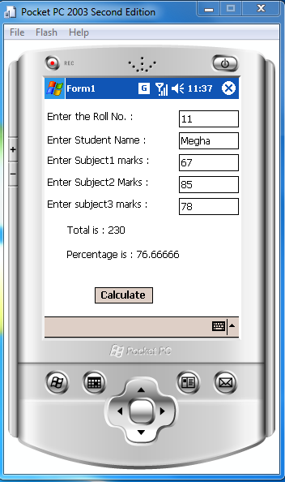

**//Design a calculator for Windows CE.net**

using System;

using System.Collections.Generic;

using System.ComponentModel;

using System.Data;

using System.Drawing;

using System.Text;

using System.Windows.Forms;

namespace program3

{

public partial class Form1 : Form

{

double op1, op2, ans;

string str;

int len,oprator;

public Form1()

{

InitializeComponent();

}

private void bdiv_Click(object sender, EventArgs e)

{

op1 = Convert.ToDouble(textBox1.Text);

textBox1.Text = "/";

oprator = 1;

}

private void bmul_Click(object sender, EventArgs e)

{

op1 = Convert.ToDouble(textBox1.Text);

textBox1.Text = "*";

oprator = 5;

}

private void bplus_Click(object sender, EventArgs e)

{

op1 = Convert.ToDouble(textBox1.Text);

textBox1.Text = "+";

oprator = 3;

}

private void bminus_Click(object sender, EventArgs e)

{

op1 = Convert.ToDouble(textBox1.Text);

textBox1.Text = "-";

oprator = 4;

}

private void bmod_Click(object sender, EventArgs e)

{

op1 = Convert.ToDouble(textBox1.Text);

textBox1.Text = "%";

oprator = 5;

}

private void bAC_Click(object sender, EventArgs e)

{

len = textBox1.Text.Length;

if (len != 0)

str = textBox1.Text.Remove(len - 1, 1);

else

textBox1.Text = "0";

textBox1.Text = str;

}

private void bcancel_Click(object sender, EventArgs e)

{

textBox1.Text = "0";

}

private void bdot_Click(object sender, EventArgs e)

{

if (textBox1.Text == "0" || textBox1.Text == "+" || textBox1.Text == "-" || textBox1.Text == "*" || textBox1.Text == "/" || textBox1.Text == "%")

{ textBox1.Text = "0."; }

else

{

textBox1.Text = textBox1.Text + ".";

}

}

private void bequal_Click(object sender, EventArgs e)

{

op2 = Convert.ToDouble(textBox1.Text);

switch (oprator)

{

case 1:

ans = op1 / op2;

break;

case 2:

ans = op1 * op2;

break;

case 3:

ans = op1 + op2;

break;

case 4:

ans = op1 - op2;

break;

case 5:

ans = (op1 * 100) / op2;

break;

}

textBox1.Text = Convert.ToString(ans);

}

private void b0_Click(object sender, EventArgs e)

{

if (textBox1.Text == "0" || textBox1.Text == "+" || textBox1.Text == "-" || textBox1.Text == "*" || textBox1.Text == "/" || textBox1.Text == "%")

textBox1.Text = "0";

else

textBox1.Text = textBox1.Text + "0";

}

private void b00_Click(object sender, EventArgs e)

{

if (textBox1.Text == "0" || textBox1.Text == "+" || textBox1.Text == "-" || textBox1.Text == "*" || textBox1.Text == "/" || textBox1.Text == "%")

textBox1.Text = "0";

else

textBox1.Text = textBox1.Text + "00";

}

private void b1_Click(object sender, EventArgs e)

{

if (textBox1.Text == "0" || textBox1.Text == "+" || textBox1.Text == "-" || textBox1.Text == "*" || textBox1.Text == "/" || textBox1.Text == "%")

textBox1.Text = "1";

else

textBox1.Text = textBox1.Text + "1";

}

private void b2_Click(object sender, EventArgs e)

{

if (textBox1.Text == "0" || textBox1.Text == "+" || textBox1.Text == "-" || textBox1.Text == "*" || textBox1.Text == "/" || textBox1.Text == "%")

textBox1.Text = "2";

else

textBox1.Text = textBox1.Text + "2";

}

private void b3_Click(object sender, EventArgs e)

{

if (textBox1.Text == "0" || textBox1.Text == "+" || textBox1.Text == "-" || textBox1.Text == "*" || textBox1.Text == "/" || textBox1.Text == "%")

textBox1.Text = "3";

else

textBox1.Text = textBox1.Text + "3";

}

private void b4_Click(object sender, EventArgs e)

{

if (textBox1.Text == "0" || textBox1.Text == "+" || textBox1.Text == "-" || textBox1.Text == "*" || textBox1.Text == "/" || textBox1.Text == "%")

textBox1.Text = "4";

else

textBox1.Text = textBox1.Text + "4";

}

private void b5_Click(object sender, EventArgs e)

{

if (textBox1.Text == "0" || textBox1.Text == "+" || textBox1.Text == "-" || textBox1.Text == "*" || textBox1.Text == "/" || textBox1.Text == "%")

textBox1.Text = "5";

else

textBox1.Text = textBox1.Text + "5";

}

private void b6_Click(object sender, EventArgs e)

{

if (textBox1.Text == "0" || textBox1.Text == "+" || textBox1.Text == "-" || textBox1.Text == "*" || textBox1.Text == "/" || textBox1.Text == "%")

textBox1.Text = "6";

else

textBox1.Text = textBox1.Text + "6";

}

private void b7_Click(object sender, EventArgs e)

{

if (textBox1.Text == "0" || textBox1.Text == "+" || textBox1.Text == "-" || textBox1.Text == "*" || textBox1.Text == "/" || textBox1.Text == "%")

textBox1.Text = "7";

else

textBox1.Text = textBox1.Text + "7";

}

private void b8_Click(object sender, EventArgs e)

{

if (textBox1.Text == "0" || textBox1.Text == "+" || textBox1.Text == "-" || textBox1.Text == "*" || textBox1.Text == "/" || textBox1.Text == "%")

textBox1.Text = "8";

else

textBox1.Text = textBox1.Text + "8";

}

private void b9_Click(object sender, EventArgs e)

{

if (textBox1.Text == "0" || textBox1.Text == "+" || textBox1.Text == "-" || textBox1.Text == "*" || textBox1.Text == "/" || textBox1.Text == "%")

textBox1.Text = "9";

else

textBox1.Text = textBox1.Text + "9";

}

}

}

**Output:**

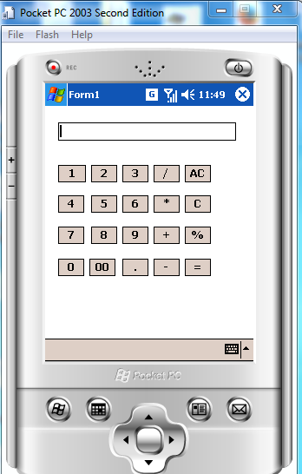 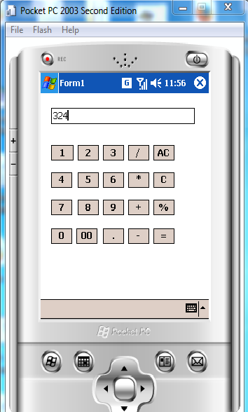 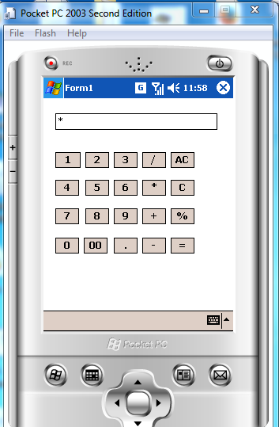 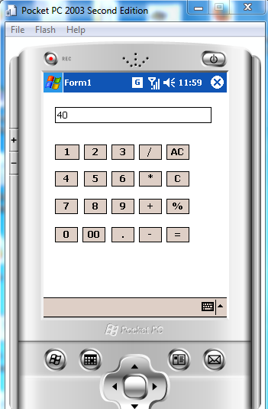 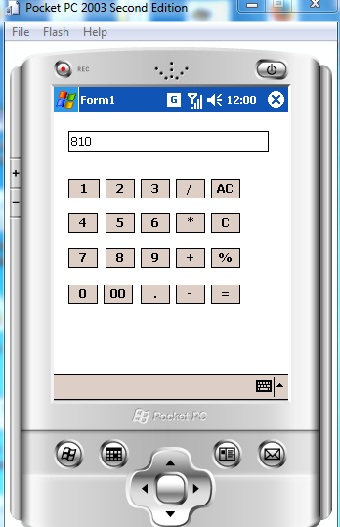

**//Write a program for menu driven Smartphone application to display formula for calculation for area for various shapes should be selected from menu(square ,triangle, rectangle and circle).**

using System;

using System.Collections.Generic;

using System.ComponentModel;

using System.Data;

using System.Drawing;

using System.Text;

using System.Windows.Forms;

namespace DeviceApplication4

{

public partial class Form1 : Form

{

Single hei, bs, rad, wid, hi, sid;

int num = 0;

public Form1()

{

InitializeComponent();

}

private void menuItem2_Click(object sender, EventArgs e)

{

num = 1;

lblHeight.Visible = true;

lblBase.Visible = true;

txtHeight.Visible = true;

txtBase.Visible = true;

txtHeight.Text = "";

txtBase.Text = "";

txtArea.Text = "";

txtHeight.Focus();

}

private void menuItem4_Click(object sender, EventArgs e)

{

num = 3;

lblHeight.Visible = true;

lblHeight.Text = "Radius";

lblBase.Visible = false;

lblHeight.Visible = true;

txtHeight.Visible = true;

txtBase.Visible = false;

txtHeight.Text = "";

txtBase.Text = "";

txtArea.Text = "";

txtHeight.Focus();

}

private void menuItem5_Click(object sender, EventArgs e)

{

num = 4;

lblHeight.Visible = true;

lblHeight.Text = "side";

// lblHeight.Visible = true;

txtHeight.Visible = true;

// txtBase.Visible = false;

txtHeight.Text = "";

// txtBase.Text = "";

txtArea.Text = "";

txtHeight.Focus();

}

private void menuItem3_Click(object sender, EventArgs e)

{

num = 2;

lblHeight.Visible = true;

lblHeight.Text = "width";

lblBase.Visible = true;

lblBase.Text = "height";

txtHeight.Visible = true;

txtBase.Visible = true;

txtHeight.Text = "";

txtBase.Text = "";

txtArea.Text = "";

txtHeight.Focus();

}

private void menuItem6_Click(object sender, EventArgs e)

{

switch (num)

{

case 1:

bs = Convert.ToSingle(txtBase.Text);

hei = Convert.ToSingle(txtHeight.Text);

txtArea.Text = ((1 / 2) * bs * hei).ToString();

break;

case 3:

rad= Convert.ToSingle(txtHeight.Text);

//hei = Convert.ToSingle(txtHeight.Text);

txtArea.Text = (Math.PI*rad *rad ).ToString();

break;

case 4:

sid = Convert.ToSingle(txtHeight.Text);

txtArea.Text = (sid*sid).ToString();

break;

case 2:

wid = Convert.ToSingle(txtBase.Text);

hi = Convert.ToSingle(txtHeight.Text);

txtArea.Text = (wid*hi).ToString();

break;

default:

txtArea.Text = "";

break;

}}}}

**Output:**

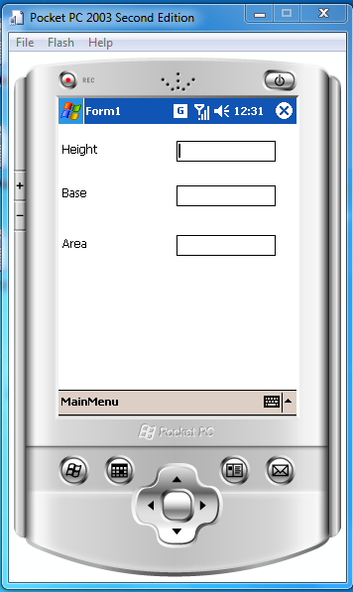 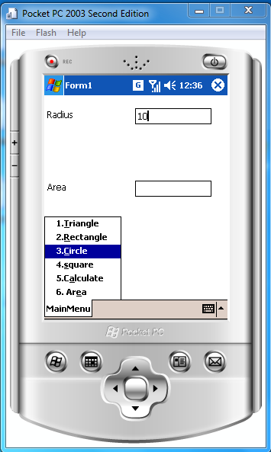 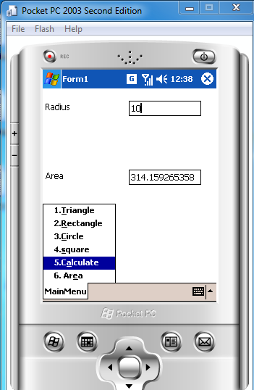

**//Design a file Viewer for Windows CE.Net**

using System;

using System.Collections.Generic;

using System.ComponentModel;

using System.Data;

using System.Drawing;

using System.Text;

using System.Windows.Forms;

using System.Diagnostics;

namespace DeviceApplication5

{

public partial class Form1 : Form

{

public Form1()

{

InitializeComponent();

}

private void btnRun_Click(object sender, EventArgs e)

{

Process p = new Process();

p.StartInfo.FileName = txtFileViewer.Text;

p.Start();

}

private void btnbrowse_Click(object sender, EventArgs e)

{

string FileName;

openFileDialog1.InitialDirectory = Environment.GetFolderPath(Environment.SpecialFolder.Personal);

openFileDialog1.Filter = openFileDialog1.Filter = "All Files(*.*)|*.*";

if (openFileDialog1.ShowDialog() == DialogResult.OK)

{

FileName = openFileDialog1.FileName;

txtFileViewer.Text = FileName;

}

}

}

}

**Output:**

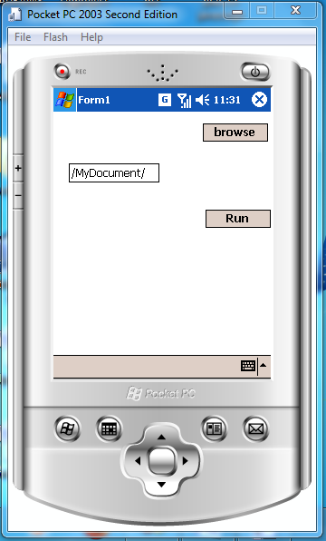 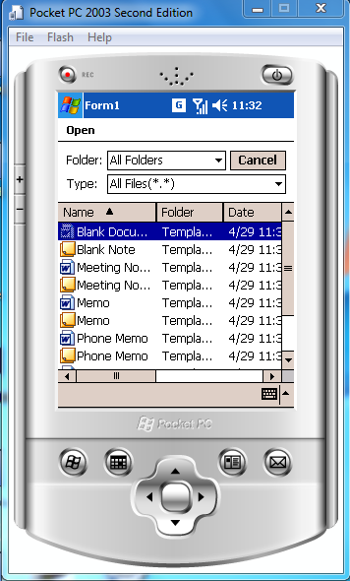 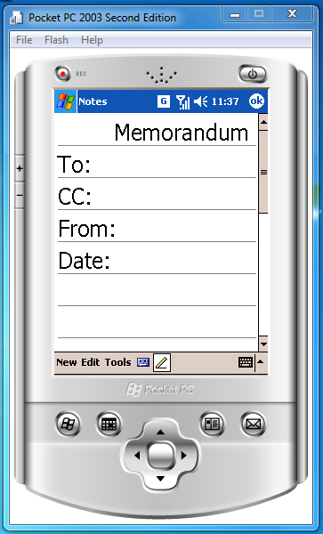

**// Write a program forimage viewer in smart device application.**

using System;

using System.Collections.Generic;

using System.ComponentModel;

using System.Data;

using System.Drawing;

using System.Text;

using System.Windows.Forms;

namespace DeviceApplicationImage9

{

public partial class Form1 : Form

{int inc=0;

int count = 0;

public Form1()

{

InitializeComponent();

}

private void menuItem1_Click(object sender, EventArgs e)

{

if (inc >= 0)

{

if (inc == count)

inc--;

pictureBox.Image = imageList.Images[inc];

if (inc == 0)

inc = 0;

else

inc--;

}

}

private void menuItem2_Click(object sender, EventArgs e)

{

if (inc <= count)

{

if (inc == 0)

inc++;

pictureBox.Image = imageList.Images[inc];

if (inc == count)

inc = count;

else

inc++;

}

}

private void Form1_Load(object sender, EventArgs e)

{

count=imageList.Images.Count-1;

pictureBox.Image=imageList.Images[0];

inc++;

}

} }

**Output:**

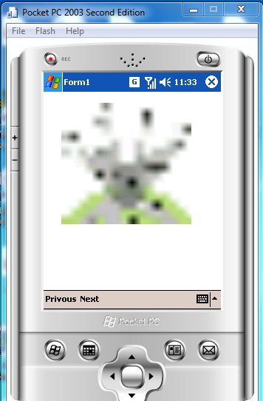 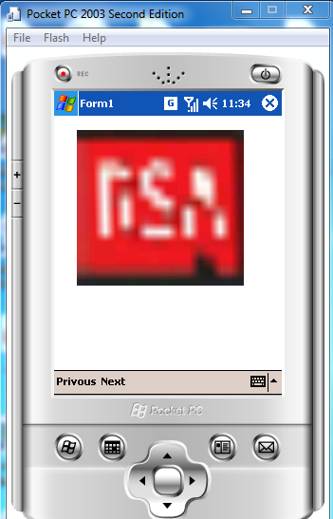

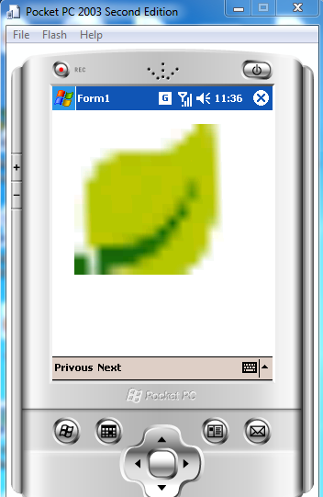

**//Write a menu driven Smartphone application to implement date picker to accept date of birth and display the current age.**

using System;

using System.Collections.Generic;

using System.ComponentModel;

using System.Data;

using System.Drawing;

using System.Text;

using System.Windows.Forms;

namespace DeviceApplication12

{

public partial class Form1 : Form

{

public Form1()

{

InitializeComponent();

}

private void menuItem1_Click(object sender, EventArgs e)

{

DateTime curTime = DateTime.Now;

int yr, month, day;

DateTime bday;

bday = Convert.ToDateTime(dateTimePicker1.Value);

month = 12 * (DateTime.Now.Year - bday.Year) + (DateTime.Now.Month - bday.Month);

if (DateTime.Now.Day < bday.Day)

{

month -= 1;

day = DateTime.DaysInMonth(bday.Year, bday.Month) - bday.Day + DateTime.Now.Day;

}

else

{

day = DateTime.Now.Day - bday.Day;

}

yr = Convert.ToInt32(Math.Floor(month / 12));

month -= yr * 12;

lblage.Text = yr + "year" + month + "Month" + day + "Days";

}

}

}

**Output:**

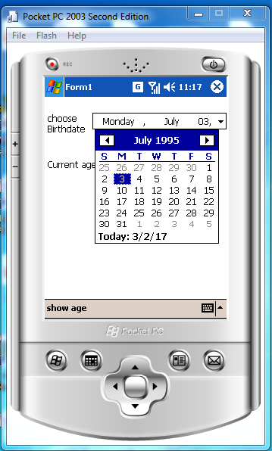 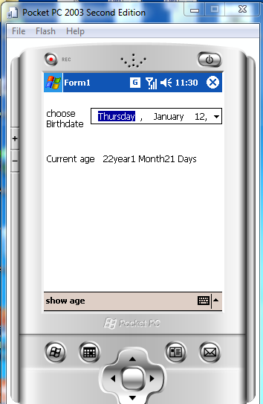

**//Write a Program in C# using delegates to printing the various formats of the strings.**

using System;

using System.Collections.Generic;

using System.ComponentModel;

using System.Data;

using System.Drawing;

using System.Text;

using System.Windows.Forms;

namespace DeviceApplication13

{

public delegate string strDelegate(string s);

public partial class Form1 : Form

{

strDelegate sd;

public Form1()

{

InitializeComponent();

}

private void lowerBtn_Click(object sender, EventArgs e)

{

sd = new strDelegate(DelegateEx.AllChrLowerCase);

labelo.Text = sd.Invoke(textBox.Text);

labelb.Text = "LowerCase";

}

private void Uppercasebtn_Click(object sender, EventArgs e)

{

sd = new strDelegate(DelegateEx.AllChrUpperCase);

labelo.Text = sd.Invoke(textBox.Text);

labelb.Text = "UpperCase";

}

private void button4_Click(object sender, EventArgs e)

{

sd = new strDelegate(DelegateEx.Encrypt);

labelo.Text = sd.Invoke(textBox.Text);

labelb.Text = "Encrypted String";

}

private void button2_Click(object sender, EventArgs e)

{

sd = new strDelegate(DelegateEx.strReverse);

labelo.Text = sd.Invoke(textBox.Text);

labelb.Text = "Reverse String";

}

private void button5_Click(object sender, EventArgs e)

{

sd = new strDelegate(DelegateEx.strremovespace); ;

labelo.Text = sd.Invoke(textBox.Text);

labelb.Text = "After Removing Space";

}

}

class DelegateEx

{

public static string AllChrLowerCase(string s)

{

string lower = s.ToLower();

return lower;

}

public static string AllChrUpperCase(string s)

{

string upper = s.ToUpper();

return upper;

}

public static string strReverse(string s)

{

int len = s.Length;

char[] arr = new char[len];

for (int i = 0; i < len; i++)

{

arr[i] = s[len - 1 - i];

}

return new string(arr);

}

public static string Encrypt(string s)

{

int len = s.Length, i=0;

char[] str = new char[len];

string str1 = "";

while (i < len) {

if (string.Compare(s[i].ToString(), str1) != 0)

str[i] = Convert.ToChar(Convert.ToInt32(s[i] + 100));

else

str[i] = ' ';

i++;

}

return new string(str);

}

public static string strremovespace(string s)

{

int len = s.Length, i=0,j=0;

char[] str = new char[len];

string str1 = " ";

while (i< len)

{

if (string.Compare(s[i].ToString(), str1) != 0)

{

str[j] = s[i];

j++;

}

i++;

}

return new string(str);

}

}

}

**Output:**



**//Write aMenu driven Smartphone application to implement list box of select names of country and display the current time of selected control.**

using System;

using System.Collections.Generic;

using System.ComponentModel;

using System.Data;

using System.Drawing;

using System.Text;

using System.Windows.Forms;

namespace DeviceApplication15

{

public partial class Form1 : Form

{

DateTime da;

DateTime dt = new DateTime();

DateTime dat;

int hr;

public Form1()

{

InitializeComponent();

}

private void comboBox1_SelectedIndexChanged(object sender, EventArgs e)

{

if ((textBox.Text == "22:15"))

{

dat = Convert.ToDateTime(dateTimePicker.Value);

da = Convert.ToDateTime(textBox.Text);

hr = da.Hour;

if (comboBox1.SelectedIndex == 0)

{

dt = da.AddHours(4).AddMinutes(30);

lblcou.Text = "Australia";

funnext();

}

if (comboBox1.SelectedIndex == 1)

{

dt = da.AddHours(4).AddMinutes(30);

lblcou.Text = "Bhutan";

funnext();

}

if (comboBox1.SelectedIndex == 2)

{

dt = da.AddHours(4).AddMinutes(30);

lblcou.Text = "Canada";

funbac();

}

if (comboBox1.SelectedIndex == 3)

{

dt = da.AddHours(4).AddMinutes(30);

lblcou.Text = "China";

funnext();

}

if (comboBox1.SelectedIndex == 4)

{

dt = da.AddHours(4).AddMinutes(30);

lblcou.Text = "France";

funbac();

}

if (comboBox1.SelectedIndex == 5)

{

dt = da.AddHours(4).AddMinutes(30);

lblcou.Text = "Nepal";

funnext();

}

if (comboBox1.SelectedIndex == 6)

{

dt = da.AddHours(4).AddMinutes(30);

lblcou.Text = "Pakistan";

funbac();

}

lblres.Text = "";

string str = dat.Month + "/" + dat.Day + "/" + dat.Year;

str = str + " " + dt.Hour.ToString() + ":" + dt.Minute.ToString();

lblres.Text = str;

}

else

textBox.Text="";

}

public void funnext()

{

int a;

if(dt.Hour>hr)

a=dt.Hour-hr;

else

a=dt.Hour;

hr =hr+a;

if(hr>=24)

dat=dat.AddDays(1);

}

public void funbac()

{

hr = hr - dt.Hour;

if (hr < 0)

dat = dat.AddDays(-1);

}

}

}

**Output:**

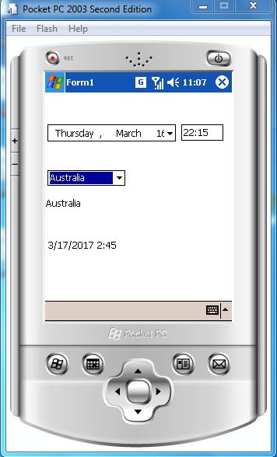

**//Write a Program for Sum of Digit**

using System;

using System.Collections.Generic;

using System.ComponentModel;

using System.Data;

using System.Drawing;

using System.Text;

using System.Windows.Forms;

namespace DeviceApplicationSumofDigit

{

public partial class Form1 : Form

{

int n, sum = 0, m;

public Form1()

{

InitializeComponent();

}

private void btnsumofDigit_Click(object sender, EventArgs e)

{

n = Convert.ToInt32(textBox1.Text);

while (n != 0)

{

m = n % 10;

sum = sum + m;

n = n / 10;

label2.Text = "sum of Digit ="+sum;

}

}

}

}

**Output:**

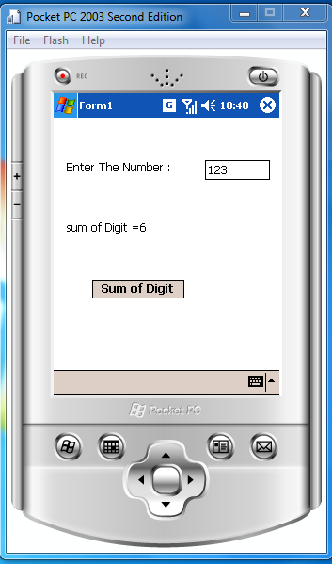

**//Write a program to check whether the entered number is an Amstrong Number or not.**

using System;

using System.Collections.Generic;

using System.ComponentModel;

using System.Data;

using System.Drawing;

using System.Text;

using System.Windows.Forms;

namespace DeviceApplicationamstrong

{

public partial class Form1 : Form

{

int num, rem, sum = 0;

public Form1()

{

InitializeComponent();

}

private void btnarmstrong_Click(object sender, EventArgs e)

{

num = Convert.ToInt32(textBox1.Text);

for (int i = num; i > 0; i = i / 10)

{

rem = i % 10;

sum = sum + rem * rem * rem;

}

if (sum == num)

{

label2.Text = "Entered no. is an armstrong no";

}

else

{

label2.Text = "Entered no is not an armstrong no";

}

}

}

}

**Output:**

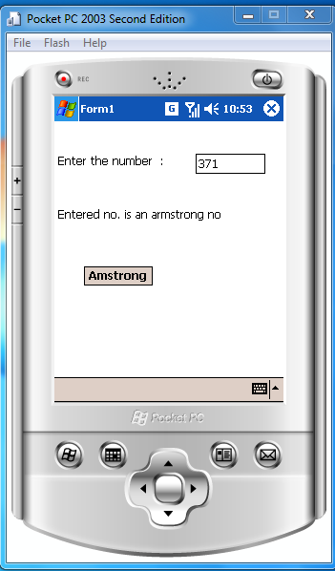

**//Write a program to check whether the given number is prime or not.**

using System;

using System.Collections.Generic;

using System.ComponentModel;

using System.Data;

using System.Drawing;

using System.Text;

using System.Windows.Forms;

namespace DeviceApplicationPrimeNo

{

public partial class Form1 : Form

{

int num, k = 0;

public Form1()

{

InitializeComponent();

}

private void label1_ParentChanged(object sender, EventArgs e)

{

}

private void btnPrime_Click(object sender, EventArgs e)

{

num = Convert.ToInt32(textBox1.Text);

for (int i = 1; i <= num; i++)

{

if (num % i == 0)

{

k++;

}

}

if (k == 2)

{

label2.Text = "Entered no is prime no ";

}

else {

label2.Text = "Entered no is not prime no";

}

}

}

}

**Output:**

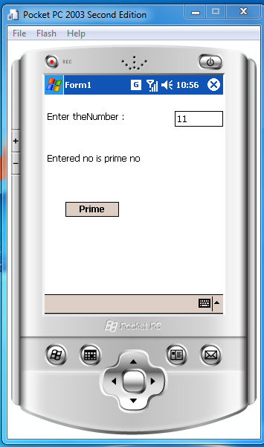

**//Write a program to add data of two objects using operator overloading**

using System;

using System.Collections.Generic;

using System.ComponentModel;

using System.Data;

using System.Drawing;

using System.Text;

using System.Windows.Forms;

namespace DeviceApplication11

{

public partial class Form1 : Form

{

public Form1()

{

InitializeComponent();

}

int l,m;

public Form1( int aa, int bb)

{

l=aa;

m=bb;

}

public int ia,ib,ic,id;

public int a

{

set{

ia=value;}

get{

return ia;}

}

public int b

{

set{

ib=value;}

get{

return ib;}

}

public int c

{

set{

ic=value;}

get{

return ic;}

}

public int d

{

set

{

id = value;

}

get

{

return id;

}

}

private void btnadd_Click(object sender, EventArgs e)

{

a = Convert.ToInt32(txtcom1r.Text);

b = Convert.ToInt32(txtcom1i.Text);

Complex obj1 = new Complex(a, b);

c = Convert.ToInt32(txtcom2r.Text);

d = Convert.ToInt32(txtcom2i.Text);

Complex obj2 = new Complex(c, d);

Complex obj = obj1 + obj2;

string faltu = obj.show();

txtresultadd.Text = faltu;

}

private void txtcom2r_TextChanged(object sender, EventArgs e)

{

txtcom1.Text = txtcom1r.Text + "+i" + txtcom1i.Text;

}

private void txtcom2i_TextChanged(object sender, EventArgs e)

{

txtcom2.Text = txtcom2r.Text + "+i" + txtcom2i.Text;

}

}

}

**Complex class**

using System;

using System.Collections.Generic;

using System.Text;

namespace DeviceApplication11

{

class Complex

{

public int x, y;

public string sans;

public string ans

{

set

{

sans = value;

}

get

{

return sans;

}

}

public Complex(int s, int t)

{

x = s;

y = t;

}

public static Complex operator +(Complex c1, Complex c2)

{

Complex temp = new Complex(0, 0);

temp.x = c1.x + c2.x;

temp.y = c1.y + c2.y;

return temp;

}

public string show()

{

string sug = x.ToString();

string des = y.ToString();

ans = sug + "+i" + des;

return ans;

}

}

}

**Output:**

